🐖 Pig Breed Coloring Booklet
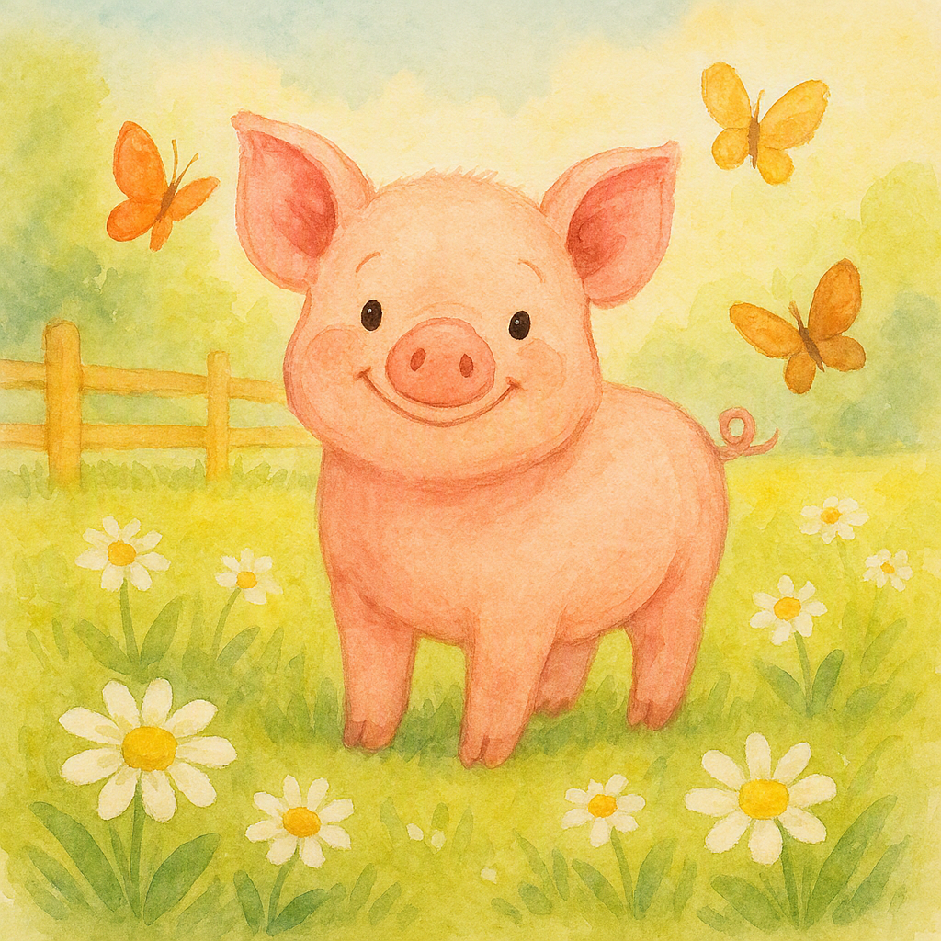

  - Color and learn about 8 different pig breeds!
This booklet includes:
- American Landrace
- Berkshire
- Chester White
- Duroc
- Hampshire
- Poland China
- Spotted Swine
- Yorkshire
Perfect for young learners, classrooms, and farm-themed activities.

American Landrace
Breed: American Landrace
Coloring: Color the pig white with drooping ears and a long body.
Description: Long body, floppy ears, rounded snout.
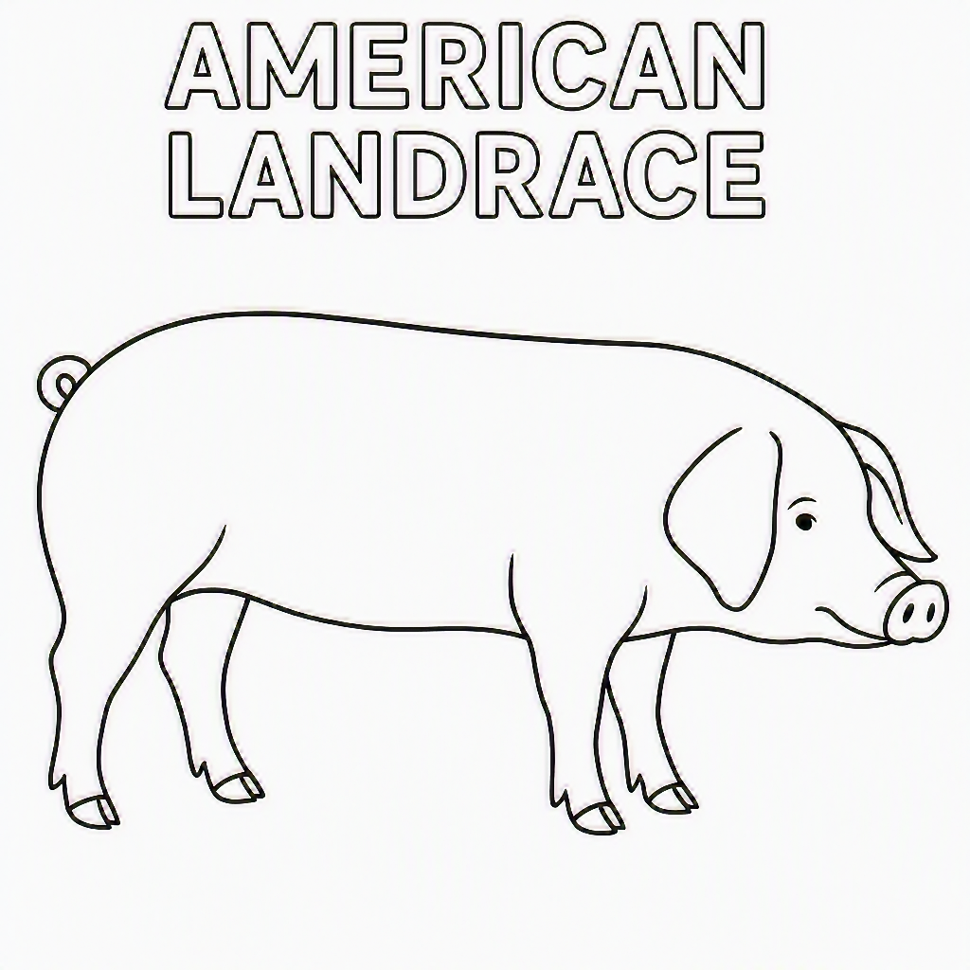

Berkshire
Breed: Berkshire
Coloring: Color the pig black with white feet, white face, and white tail tip.
Description: Medium body, pointy ears, short snout.
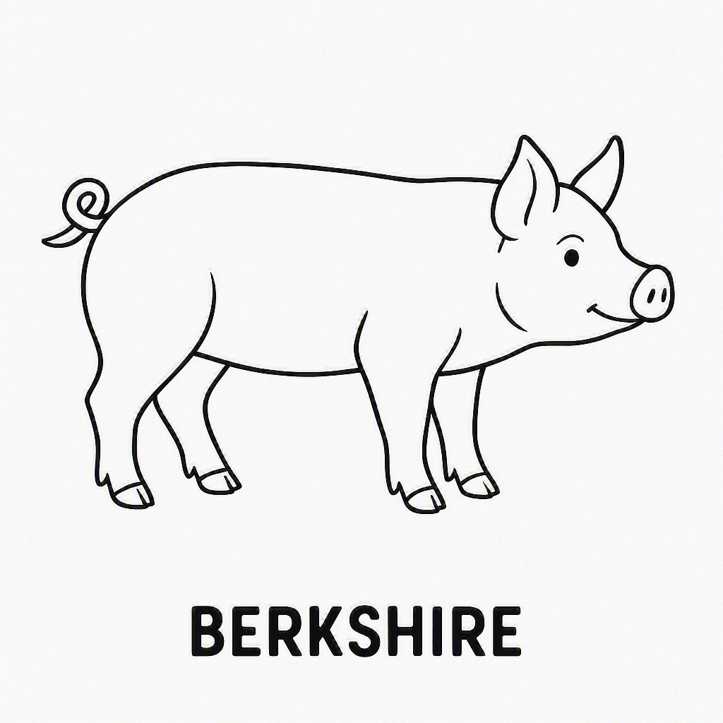

Chester White
Breed: Chester White
Coloring: Color the pig white with drooping ears.
Description: Rounded body, floppy ears.
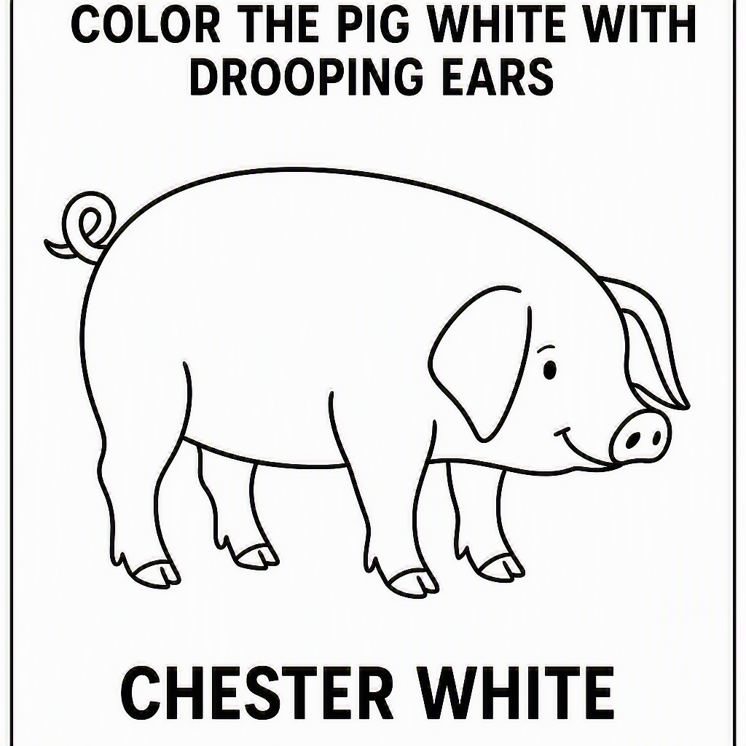

Duroc
Breed: Duroc
Coloring: Color the pig red or reddish-brown.
Description: Medium body, floppy ears, thicker neck.
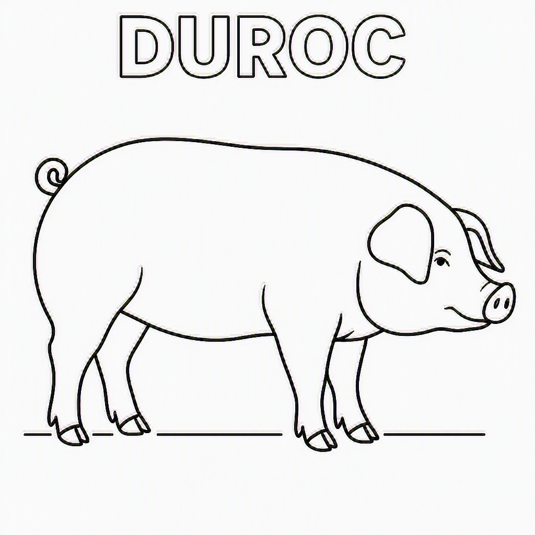

Hampshire
Breed: Hampshire
Coloring: Color the pig black with a white band around the shoulders and front legs.
Description: Medium body, pointy ears, blank shoulder band area.

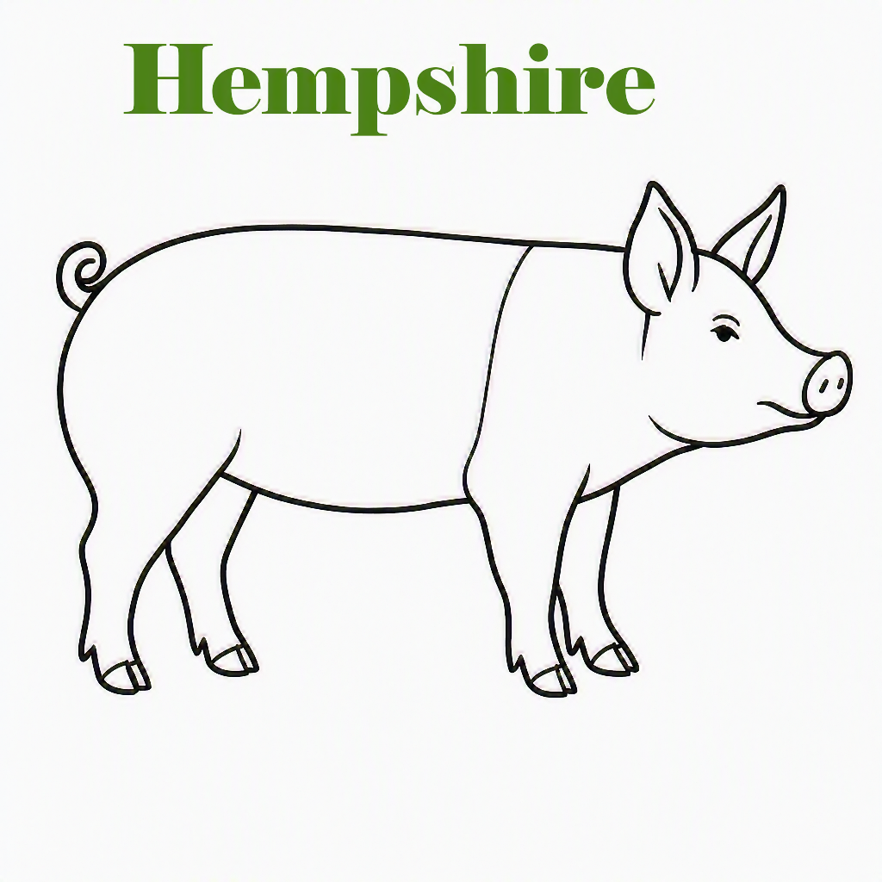

Poland China
Breed: Poland China
Coloring: Color the pig black with white feet, white face, and white tail tip.
Description: Heavier belly, floppy ears.
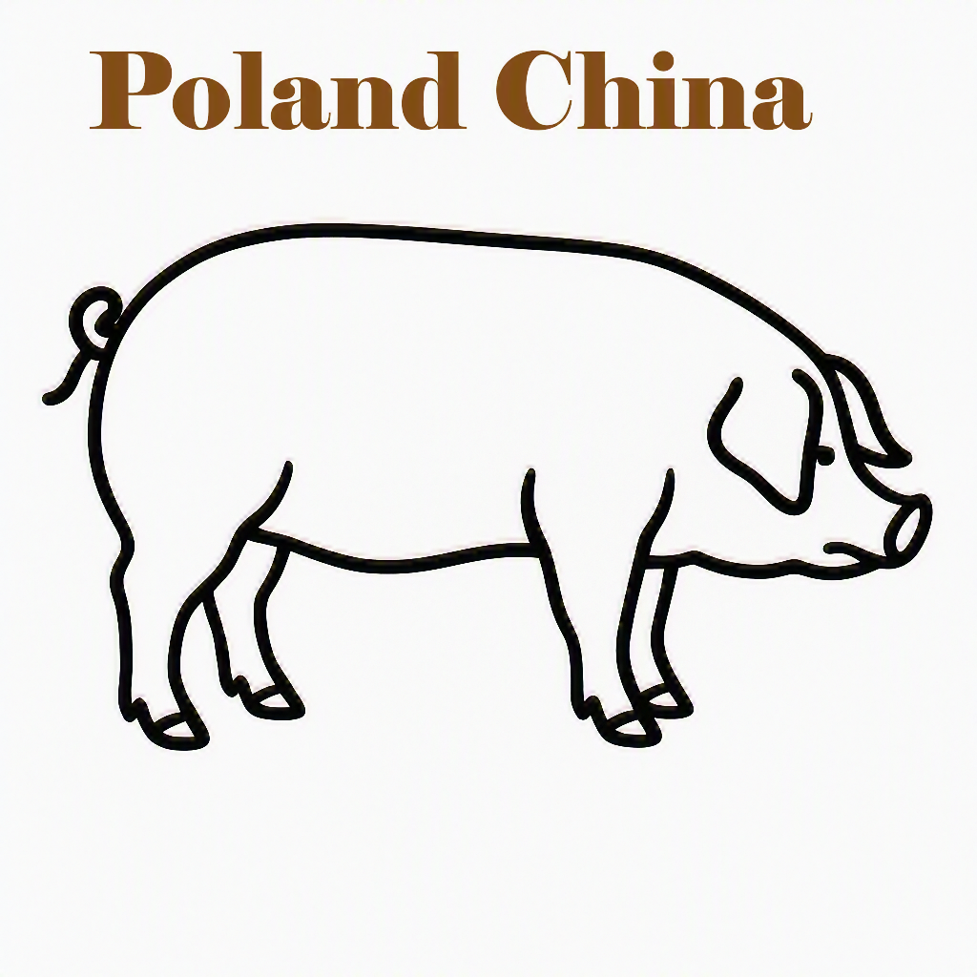

Spotted Swine
Breed: Spotted Swine
Coloring Prompt: Color the pig white with black spots. Outline
Description: Round body, blank for spots.

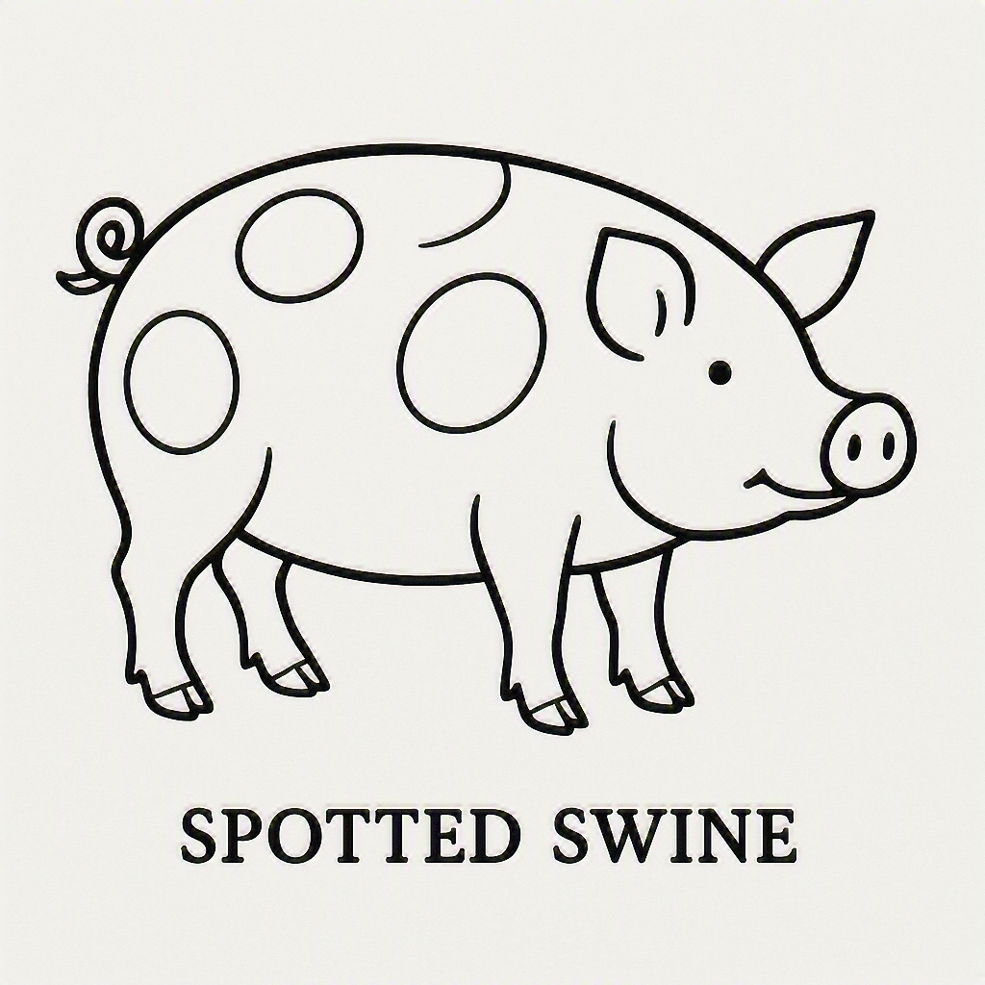

Yorkshire
Breed: Yorkshire
Coloring: Color the pig white with pointy ears.
Description: Long body, erect ears.

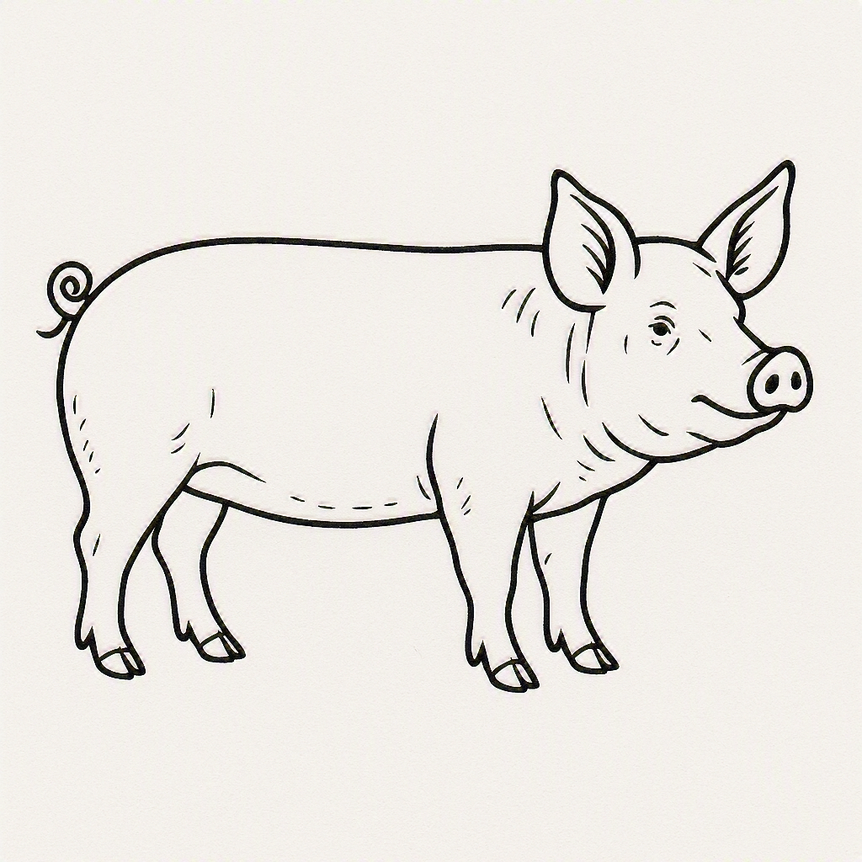

Fun Pig Facts for Kids!
- Pigs are super smart!
They can learn tricks, recognize their names, and even play simple games.
- Pigs love to stay clean.
They roll in mud to stay cool — not because they’re dirty. 3.
- Piglets learn to squeal differently.
Each piglet has its own “voice,” just like people.
- Pigs have great memories.
They remember places, people, and other animals.
- Pigs communicate with more than 20 sounds.
Grunts, squeals, snorts — each one means something different.
- A group of pigs is called a herd.
And a group of baby pigs born at the same time is called a litter.
- Pigs can run fast!
Some pigs can sprint up to 11 miles per hour.

